DESIGN AND ANALYSIS OF ALGORITHMS LABORATORY
(Common to CSE & ISE)

Subject Code: 10CSL47 I.A. Marks: 25
Hours/Week: 03 Exam Hours: 03
Total Hours : 42 Exam Marks: 50

Design, develop and implement the specified algorithms for the following problems using C/C++ Language in LINUX /Windows environment.

1.Sort a given set of elements using the Quicksort method and determine the time required to
sort the elements. Repeat the experiment for different values of n, the number of elements in
the list to be sorted and plot a graph of the time taken versus n. The elements can be read from
a file or can be generated using the random number generator.

2.Using OpenMP, implement a parallelized Merge Sort algorithm to sort a given set of elements
and determine the time required to sort the elements. Repeat the experiment for different
values of n, the number of elements in the list to be sorted and plot a graph of the time taken
versus n. The elements can be read from a file or can be generated using the random number
generator.

3. a. Obtain the Topological ordering of vertices in a given digraph.
b. Compute the transitive closure of a given directed graph usingWarshall's
algorithm.

4. Implement 0/1 Knapsack problem using DynamicProgramming.

5. From a given vertex in a weighted connected graph, find shortest paths to other vertices using
Dijkstra's algorithm.

6. Find Minimum Cost Spanning Tree of a given undirected graph usingKruskal's algorithm.

7. a. Print all the nodes reachable from a given starting node in a digraph using BFS method.
b. Check whether a given graph is connected or not using DFS method.

8. Find a subset of a given set S = {sl, s2,.....,sn} of n positive integerswhose sum is equal to a
given positive integer d. For example, if S={1, 2, 5, 6, 8} and d = 9 there are two
solutions {1,2,6}and{1,8}.A suitable message is to be displayed if the given problem instance
doesn't have a solution.

9. Implement any scheme to find the optimal solution for the Traveling Salesperson problem and
then solve the same problem instanceusing any approximation algorithm and determine the
error in the approximation.

10. Find Minimum Cost Spanning Tree of a given undirected graph using Prim’s algorithm.

11. Implement All-Pairs Shortest Paths Problem using Floyd's algorithm. Parallelize this
Algorithm, implement it using OpenMP and determine the speed-up achieved.

12. Implement N Queen's problem using Back Tracking.

Note: In the examination each student picks one question from the lot of all 12 questions.

INTRODUCTION

Need for studying algorithms

Theoretical importance
- The study of algorithms is the corner stone of computer science.
- It is a standard set of important algorithms,they further our analytical skills & help us in developing new algorithms for required applications

Algorithm
An algorithm is a sequence of unambiguous instructions for solving a problem, i.e., for obtaining a required output for any legitimate input in a finite amount of time.
In addition, all algorithms must satisfy the following criteria:

- Input: Each algorithm should have zero or more inputs. The range of input for
which algorithms works should be specified carefully.
- Output: The algorithm should produce correct results. At least one quantity has to
be produced.
- Definiteness: Each instruction should be clear and unambiguous.
- Effectiveness: Every instruction should be simple and should transform the
given input to the desired output. so that it can be carried out, in
- Finiteness: If we trace out the instruction of an algorithm, then for all cases, the
algorithm must terminates after a finite number of steps.

Notion of algorithm

“Computer”
Problem
Algorithm
Input
Output

Fundamentals of Algorithmic problem solving

• Understanding the problem
• Ascertain the capabilities of the computational device
• Exact /approximate solution.
• Decide on the appropriate data structure
• Algorithm design techniques
• Methods of specifying an algorithm
• Proving an algorithms correctness
• Analysing an algorithm

Important Problem Types of different categories

• Sorting
It refers to the problem of re-arranging the items of a given list in ascending or
descending order.
The various algorithms that can be used for sorting are bubble sort, selectionsort,insertion
sort, quick sort, merge sort, heap sort etc.
• Searching
This problem deals with finding a value, called a search key, in a given set.
The various algorithms that can be used for searching are binary search,linear
search,hashing,interpolation search etc.
• String processing
This problem deals with manipulation of characters or strings, string matching,search
and replace,deleting a string in a text etc.
String processing algorithm such as string matching algorithms are used in the
design of assemblers and compliers.
• Graph problems
The graph is a collection of vertices and edges.
The graph problems involves graph traversal algorithms,shortest path algorithms and
topological sorting and so on.
Ex:graph traversal problems, topological sorting etc
• Combinatorial problems
This problems are used to find combinatorial object such as permutation and
combinations .
Ex: travelling salesman problem, graph coloring problem etc
• Geometric problems
This problem deal with geometric objects such as points,curves,lines,polygon etc.
Ex: closest-pair problem,Convex hull problem
• Numerical problems
This problems involving mathematical manipulations such as solving
equations,computingdifferntiations and integrations,evaluating various types of
functions etc.
Ex: Gauss elimination method, Newton-Raphsonmethid

Fundamentals of data Structures
Since most of the algorithms operate on the data, particular ways of arranging the data play a critical role in the design & analysis of algorithms.
A data structure can be defined as a particularway of arrangement of data.

The commonly used data structures are:
1.Linear data structures
2.Graphs
3.Trees.
4.Sets and dictionaries

1.Linear data structures
The most common linear data structures are arrays and linked lists.
Arrays
Array is a collection of homogeneous items An item’s place within the
collection is called an index.
Linked list:
A list is a finite sequence of data items i.e. it is a collection of data items in a
certain order.

2. Graphs
A data structure that consists of a set of nodes and a set of edges that relate the nodes
to each other is called a graph.
Undirected graph: A graph in which the edges have no direction
Directed graph (Digraph): A graph in which each edge is directed from one vertex to
another (or the same) vertex.

3. Tree
A tree is a connected acyclic graph that has no cycle.

4. Sets and dictionaries
A set is defined as an unordered collection of distinct items called an element of the set
Dictionary is a data structure that implements searching,adding and deleting an item of
the set.

Analysis of algorithms
Analysis of algorithms means to investigate an algorithm’s efficiency with
respect to resources:
• Running time ( time efficiency )
It indicates how fast an algorithm in question runs
• Memory space ( space efficiency )
It deals with the extra space the algorithm requires

Theortical analysis of time efficiency
Algorithm efficiency depends on the input size n. And for some algorithms
efficiency depends on type of input.

We have best, worst & average case efficiencies

Worst-case efficiency:
Efficiency (number of times the basic operation will be executed) for the worst case
input of size n. i.e. The algorithm runs the longest among all possible inputs of size n.

Best-case efficiency:
Efficiency (number of times the basic operation will be executed for the best case input
of size n. i.e. The algorithm runs the fastest among all possible inputs of size n.

Average-case efficiency
Average time taken (number of times the basic operation will be executed) to solve all
the possible instances (random) of the input.

Asymptotic Notations
Asymptotic notation is a way of comparing functions that ignores constant factors and
small input sizes.
Three notations used to compare orders of growth of an algorithm’s basic operation count are: O, Ω, θ notations.

Big-oh notation:
A function t(n) is said to be in O(g(n)),denoted t(n)€O(g(n)),if t(n) is bounded above by some constant multiple of g(n) for all large n i.e., if there exist some positive constant c and some nonnegative integer n۪₀ such that t (n)<=cg(n) for all n>= n₀
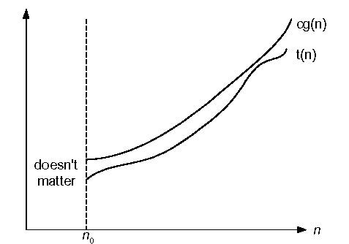
Big-oh notation t(n)€ O(g(n))

Big-omega notation:
A function t(n) is said to be in Ω(g(n)),denoted t(n)€ Ω(g(n)),if t(n) is bounded below by some constant multiple of g(n) for all large n i.e., if there exist some positive constant c and some nonnegative integer n۪₀ such that
t(n)>=cg(n) for all n>=n₀
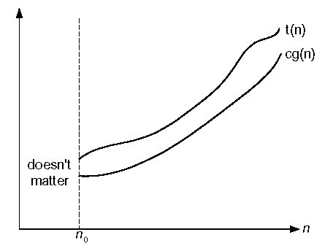
Big-omega notation t(n)€Ω, (g(n))

Big-theta notation:
A function t(n) is said to be in θ(g(n)),denoted t(n)€ θ(g(n)),if t(n) is bounded both above and below by some positive constant multiple of g(n) for all large n i.e., if there exist some positive constant c and some nonnegative integer n۪₀ such that
c2g(n)<=t(n)<=c1g(n) for all n>= n₀
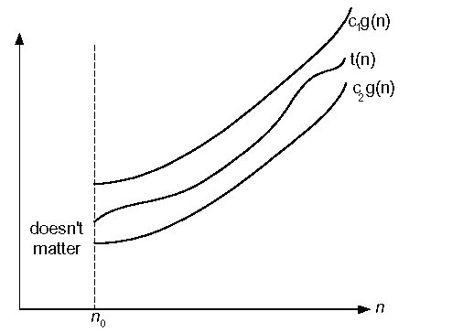

Big-theta notation t(n)€θ(g(n))

Basic Asymptotic Efficiency classes:

1 | constant
log n | logarithmic
N | linear
n log n | n log n
n² | quadratic
n³ | cubic
2^{n} | exponential
n! | factorial

PROGRAM-1

Sort a given set of elements using the Quick sort method and determine the time required to sort the elements. Repeat the experiment for different values of n, the number of elements in the list to be sorted and plot a graph of the time taken versus the elements can be read from a file or can be generated using the random number generator.

Quicksort is well-known sorting algorithms based on the divide and conquer technique.
Quicksort divides its input elements according to their value. Specifically, it rearranges elements of a given array A[0……..n-1] to achieve its partition, a situation where all the elements before some position s are smaller than or equal to A[s] and all the elements after some position s are greater than or equal to A[s].We call this element the pivot.

A[0]…A[s-1] A[s] A[s+1]…A[n-1]

All are <=A[s] all are >=A[s]

After a partition has been achieved, A[s] will be in its final position in the sorted array, and we can continue sorting the two sub arrays of the elements preceding and following A[s] independently.

Features:
• Developed by C.A.R. Hoare
• Efficient algorithm
• NOT stable sort
• Significantly faster in practice, than other algorithms

Time Complexity:
C_{best} (n) =2 C_{best} (n/2) +n for n>1 C_{best} (1) =0
Cworst(n) ∈θ(n²)
Cavg(n) ≈ 1.38nlog₂n

ALGORITHM

Quicksort(A [l...r] )
// Sorts a subarray by quicksort
// Input : A subarray A [l...r] of A [0...n-1], defined by its left and right
indices l and r
// Output : The subarray A [l...r] sorted in nondecreasing order if l< r

s ← partition ( A [l...r] ) //s in a split position
Quicksort( A [l...s-1] )
Quicksort( A [s+1...r] )
ALGORITHM

Partition ( A [l...r] )

// Partitions a subarray by using int first element as a pivot

// Input :Asubarray A [l...r] of A [0...n-1], defined by its left and right
indicesl and r (l<r)

// Output :A partition of A [l...r], with the split position returned as this
function’s value

P ← A [l]
i ← l ; j ← r + 1

repeat
repeat i ← i + 1 until A [i] >= p
repeat j ← j – 1 until A [j] <= p
swap ( A [i] , A [j] )
until i > = j

swap ( A [i] , A [j] ) // undo the last swap when i > = j
swap ( A [l] , A [j] )
return j

1. Sort the set of elements using Quick Sort method and determine time required to sort
the elements. Repeat the experiment for different values of n,the number of elements in the list to be sorted and plot a graph of time taken versus n.

#include<stdio.h>
#include<stdlib.h>
#include<time.h>
int par(int a[],int low,int high)
{
int i,j,temp,key;
i=low+1;
j=high;
key=a[low];
while(1)
{
while(i<high&&key>=a[i])
i++;
while(key<a[j])
j--;
if(i<j)
{
temp=a[i];
a[i]=a[j];
a[j]=temp;
}
else
{
temp=a[low];
a[low]=a[j];
a[j]=temp;
return j;
}
}
}
void quick(int a[],int low,int high)
{
int j;
if(low<high)
{
j=par(a,low,high);
quick(a,low,j-1);
quick(a,j+1,high);
}
}
void main()
{
int a[5000],i,n,p,q;
double duration;
clock_t start,end;
printf("ENTER THE NUMBER OF ELEMENTS\n");
scanf("%d",&n);
i=0;
for(i=0;i<n;i++)
{
a[i]=rand()%5000;
printf("%d\n",a[i]);
}
start=clock();
for(p=0;p<=1000;p++)
for(q=0;q<=1000;q++)
quick(a,0,n-1);
end=clock();
printf("THE SORTED ELEMENTS ARE\n");
for(i=0;i<n;i++)
{
printf("%d\n",a[i]);
}
duration=(double)(end-start)/CLOCKS_PER_SEC;
printf("THE TIME COMPLEXITY IS %f\n",duration);
}

OUTPUT:

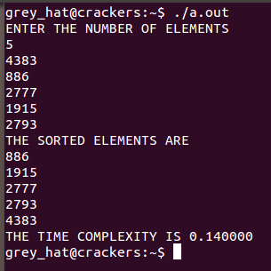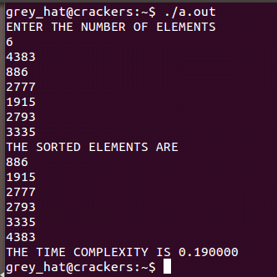

PROGRAM-2

Using Open MP, implement a parallelized Merge Sort algorithm to sort a given set of elements and determine the time required to sort the elements. Repeat the experiment for different values of n, the number of elements in the list to be sorted and plot a graph of the time taken versus n. The elements can be read from a file or can be generated using the random number generator

Merge sort is a perfect example of divide &conquer technique.

The steps are:

- Merge sort works by dividing the given array into two sub arrays of equal size
It sorts a given array A[0...n-1] by dividing it into two groups A[0...(n/2)-1] and
A[(n/2)...n-1].
- The sub arrays are sorted independently using recursion
- The sorted sub array are then merged to get the solution for the original array

Features:

• Is a comparison based algorithm
• Is a stable algorithm
• It was invented by John Von Neumann

Time Complexity:
- All cases have same efficiency: Θ( n log n)
- Number of comparisons is close to theoretical minimum for comparison-based sorting:
logn ! ≈ nlgn - 1.44 n
- Space requirement: Θ( n ) (NOT in-place)
The merge sort consists of several passes over the records being sorted. In the first pass files of size one are merged. In the second pass the size of the files being merged is two. In the i^{th} pass the files being merged will be of size 2^{i-1}. A total of log₂n passes are made over the data. Since, two files can be merged in linear time, each pass of merge sort takes O(n) time. As there are log₂n passes the total time complexity is O(n log₂n)

Algorithm
Mergesort(A[0...n-1])
//Sorts array A[0...n-1] by recursive mergesort.
//Input an array A[0...n-1] of orderable elements.
// Output Array A[0...n-1] sorted in non-decreasing order.

If n>1
Copy A[0...(n/2)-1] to B[0...(n/2)-1]
Copy A[(n/2)...n-1], to C[0...(n/2)-1]
Mergesort(B[0...(n/2)-1])
Mergesort(C[0...(n/2)-1])
Merge(B,C,A)
Algorithm
Merge(B[0...p-1],C[0...q-1],A[0...p+q-1])
//Merges two sorted arrays into one sorted array
//Input : Arrays B[0...p-1] and C[0...q-1] both sorted
//Output : Sorted array A[0...p+q-1] of the elements of B and C
i ← 0 ; j ← 0 ; k ← 0 ;
while i < p and j < q do
if B[i] <= C[j]
A[k] ← B[i] ; i ← i + 1
elseA[k] ← C[j] ; j ← j + 1
k ← k + 1
if i = p
copy C[j...q-1] to A[k...p+q-1]
else copy B[i...p-1] to A[k...p+q-q]

Time Complexity
C (n) € Θ (nlogn)

2. Using OpenMP, implement parallelized Merge Sort algorithm to sort a given set of elements and determine the time required to sort a given set of elements.Repeat teh experiment for different values of n,the number of elements in the list to be sorted and plot a graph of time taken versus n.

#include<stdio.h>
#include<time.h>
#include<omp.h>
int MAX;
void mergesort(int [],int,int);
void merge(int [],int,int,int);
void main()
{
printf("ENTER ELEMENTS\n");
scanf("%d",&MAX);
int i,n=MAX,x,y,z,a[MAX];
clock_t t1,t2;
double t3;
for(i=0;i<MAX;i++)
a[i]=(1+rand())%100;
printf("THE UNSORTED ARRAY IS\n");
for(i=0;i<MAX;i++)
printf("%d\n",a[i]);
t1=clock();
for(x=0;x<1000;x++)
#pragma omp parallel
{
#pragma omp single
if(x==0)
printf("THE NUMBER OF THREADS ARE:%d\n",omp_get_num_threads());
mergesort(a,0,n-1);
}
t2=clock();
printf("AFTER SORTING\n");
for(i=0;i<MAX;i++)
printf("%d\n",a[i]);
printf("THE DATA SET IS %d\n",n);
t3=(double)(t2-t1)/CLOCKS_PER_SEC;
printf("\nTIME TAKEN BY PARALLEL MERGESORT IS\n");
printf("t1=%d,t2=%d,t3=%f\n",t1,t2,t3);
}
void mergesort(int a[],int low,int high)
{
int mid;
if(low<high)
{mid=(low+high)/2;
{
#pragma omp task
mergesort(a,low,mid);
#pragma omp task
mergesort(a,mid+1,high);
}
#pragma omp taskwait
merge(a,low,mid,high);
}
}
void merge(int a[],int low,int mid,int high)
{
int i,j,k,h,b[MAX];
h=i=low;
j=mid+1;
while((h<=mid)&&(j<=high))
if(a[h]<a[j])
b[i++]=a[h++];
else
b[i++]=a[j++];
if(h>mid)
for(k=j;k<=high;k++)
b[i++]=a[k];
else
for(k=h;k<=mid;k++)
b[i++]=a[k];
for(k=low;k<=high;k++)
a[k]=b[k];
}

OUTPUT:

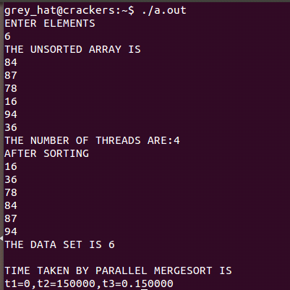
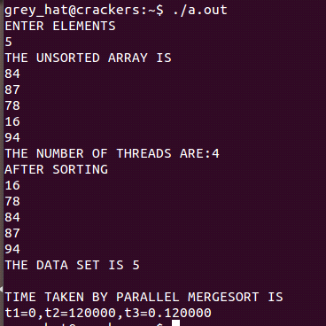

NOTE:

As this is parallel program number of threads created depends on system architecture.

3. a. Obtain the Topological ordering of vertices in a given digraph.
b. Compute the transitive closure of a given directed graph using
Warshall’s algorithm

3a. Obtain the Topological ordering of vertices in a given digraph.
Topological sorting refers to the process of visiting the vertices of a given graph in
such an order that all the independent vertices are visited first followed by the dependent
vertices.

Topological sorting problem can be solved by using
1. DFS method
2. Source removal method

DFS Method:
• Perform DFS traversal and note the order in which vertices become dead
end(popped order)
• Reverse the order, yield the topological sorting

Source removal method:
• Purely based on decrease & conquer
• Repeatedly identify in a remaining digraph a source, which is a vertex with
no incoming edges
• Delete it along with all the edges outgoing from it.

Algorithm Topological sort() //Source removal method
// Input: Adjacency matrix and number of vertices
//Output: Topological order
step1. //Obtain the in degree of each vertex
for(i= 1 to n) do
sum =0;
for(j=1 to n ) do
sum=sum+a[j][i]
endfor
indeg[i]=sum
endfor
step2: //push the indegree 0 vertices on the stack
for(i=1 to n) do
if (indeg[i]==0)
top=top+1
s[top]=i
end if
end for
step3:// find the topological sequence
while(top!=1)
u=s[top], top=top-1
add vertex u to the solution vector T
for each vertex V adjacent to U
decrement indegree of V by 1
if(indeg[v]==0)
top=top+1;
s[top]=v
endif
endfor
endwhile
step4:// display the topological order in T

Time complexity expression:
For adjacencymatrix T(n) = 0|v|²
For adjacency linked list T(n) = 0[|v| + |E|]

Program:

#include<stdio.h>
#include<stdlib.h>
#include<time.h>
int find_min(int indegree[],int n)
{
int i,min=1;
for(i=2;i<=n;i++)
if(indegree[i]<indegree[min])
min=i;
return min;
}
int main()
{
int h=0,n,x,y,i,j,a[100][100],indegree[100],count,min;
clock_t t1,t2;
double t3;
printf("ENTER NUMBER OF NODES\n");
scanf("%d",&n);
printf("ENTER THE ADJACENCY MATRIX\n");
for(i=1;i<=n;i++)
for(j=1;j<=n;j++)
scanf("%d",&a[i][j]);
for(i=1;i<=n;i++)
{ count=0;
for(j=1;j<=n;j++)
if(a[j][i]==1)
count++;
indegree[i]=count;
}
t1=clock();
printf("TOPOLOGICAL SORT ORDER\n");
while(h!=n)
{
for(x=0;x<5000;x++)
for(y=0;y<500;y++)
min=find_min(indegree,n);
printf("%d\n",min);
indegree[min]=999;
for(i=1;i<=n;i++)
if(a[min][i]==1)
indegree[i]--;
h++;
}
t2=clock();
t3=(double)(t2-t1)/CLOCKS_PER_SEC;
printf("\nTIME TAKEN\n");
printf("t1=%d,t2=%d,t3=%f\n",t1,t2,t3);
}

OUTPUT:

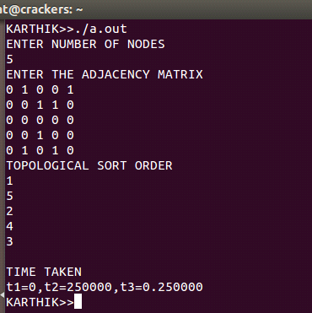

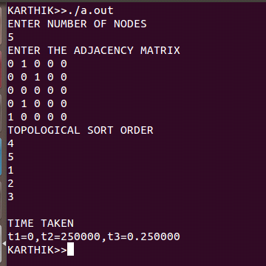

3b. Compute the transitive closure of a given directed graph using Warshall's
algorithm.

The transitive closure of a directed graph with n vertices can be defined as the n-by-n boolean matrix T={t_{ij}}, in which the element in the ith row(1<=i<=n) and jth column(1<=j<=n) is 1 if there exists a non-trivial directed path from ith vertex to jth vertex, otherwise, t_{ij} is 0.
Warshall’s algorithm constructs the transitive closure of a given digraph with n vertices through a series of n-by-n boolean matrices: R⁽⁰⁾ ,….,R^{(k-1)} , R^{(k)} ,….,R^{(n)} where,R⁽⁰⁾ is the adjacency matrix of digraph and R⁽¹⁾ contains the information about paths that use the first vertex as intermediate.
In general, each subsequent matrix in series has one more vertex to use as intermediate for its path than its predecessor. The last matrix in the series R^{(n)} reflects paths that can use all n vertices of the digraph as intermediate and finally transitive closure is obtained. The central point of the algorithm is that we compute all the elements of each matrix R^{(k)} from its immediate predecessor R ^{(k-1)} in series.
Algorithm
Warshall(A[1…n, 1…n])
//Implements Warshall’s algorithm for computing the transitive closure
//Input:The adjacency matrix A of a diagraph with n vertices
//Output:The transitive closure of diagraph
R⁽⁰⁾←A
for k←1 to n do
for i←1 to n do
for j←1 to n do
R^{(k)} [i,j] ←R^{(k-1)}[i,j] or (R^{(k-1)}[i,k] and R^{(k-1)}[k,j])
Return R^{(n)}

Complexity:
The time efficiency of Warshall’s algorithm is in Θ (n³).

3. (b) Compute the trasitive closure of a given directed graph using Warshall's alogorithm

#include<stdio.h>
#include<stdlib.h>
#include<time.h>
void warshall(int p[10][10],int n)
{
int i,j,k;
for(k=1;k<=n;k++)
{
printf("MATRIX R(%d) is\n",k);
for(i=1;i<=n;i++)
for(j=1;j<=n;j++)
p[i][j]=p[i][j]||p[i][k]&&p[k][j];
for(i=1;i<=n;i++)
{
for(j=1;j<=n;j++)
printf("%d\t",p[i][j]);
printf("\n");
}
}
}
int main()
{
int p[10][10],i,j,n;
clock_t t1,t2;
long int u,v;
double t3;
printf("ENTER NUMBER OF VERTICES\n");
scanf("%d",&n);
printf("ENTER THE ADJACENCY MATRIX\n");
for(i=1;i<=n;i++)
for(j=1;j<=n;j++)
scanf("%d",&p[i][j]);
t1=clock();
for(u=0;u<10000;u++)
for(v=0;v<1000;v++);
warshall(p,n);
t2=clock();
t3=(double)(t2-t1)/CLOCKS_PER_SEC;
printf("\nTIME TAKEN\n");
printf("t1=%d,t2=%d,t3=%f\n",t1,t2,t3);
}

OUTPUT:
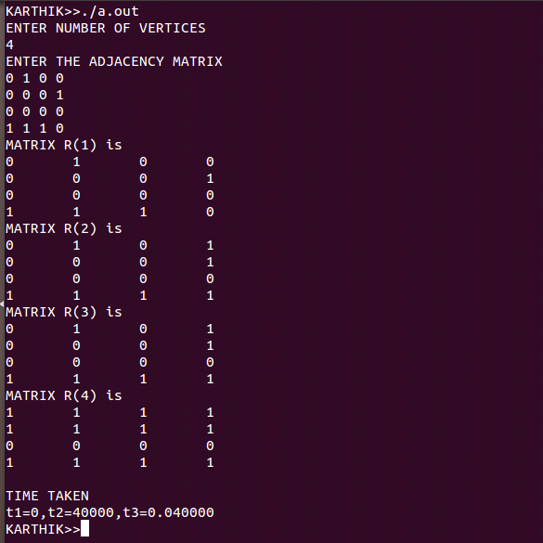

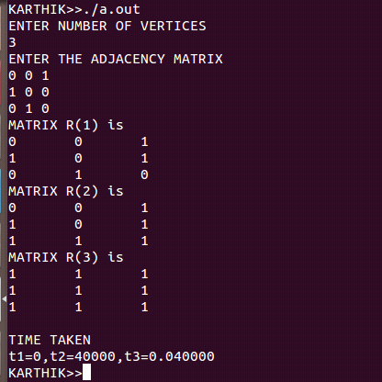

PROGRAM-4

Implement 0/1 Knapsack problem using Dynamic Programming.

Dynamic programming is a technique for solving problems with overlapping sub
problems. This method works by dividing the problem into sub problems using which the
solutions for the given problem can be obtained. Once a sub problem is solved, the result is
stored in a table and never recalculated when a sub-problem of an earlier instance is
encountered instead of recalculating the values. It is simply retrieved from tables thus saving
the time.
In a knapsack problem there is a knapsack or a container of capacity M and n items
where, each item i is of weight w_{i} and is associated with a profit p_{i}. The problem of
knapsack is to fill the available items into the knapsack so that the knapsack gets filled up
and yields a maximum profit.
If a fraction x_{i}, 0, of object i is placed into the knapsack, then a profit p_{i}x_{i} is
earned. The constrain is to obtain a filling of the knapsack that maximizes the total profit
earned. Since the knapsack capacity is m, we required the total weight of all chosen objects to
be at most m.

The steps are:

Step 1:
Identify the smaller sub-problems. If items are labeled 1..n, then a sub-problem would be to find an optimal solution for Sk = {items labeled 1, 2, .. k}

Step 2:
Recursively define the value of an optimal solution in terms of solutions to smaller
problems.

Initial conditions:
V[ 0, j ] = 0 for j ≥0
V[ i, 0 ] = 0 for i ≥0
Recursive step:
max { V[ i-1, j ], vi +V[ i-1, j - wi ] }
V[ i, j ] = if j - wi_ 0
V[ i-1, j ] if j - wi< 0

Step 3:
Bottom up computation using iteration

ALGORITHM:

Knapsack (i, j )

//Input: A nonnegative integer i indicating the number of the first items being considered and a
non negative integer j indicating the Knapsack’s capacity.

//Output: The value of an optimal feasible subset of the first i items.

//Note: Uses as global variables input arrays Weights [1...n ], Values [ 1… n ] and table
V [0…n, 0…W ] whose entries are initialized with -1’s except for row 0 and
column 0 initialized with 0’s.

if V [i, j] < 0

if j< Weights[i] then
value = Knapsack ( i-1, j )

else
value = max ( Knapsack ( i -1, j ),
values[I] + Knapsack ( i-1, j-Weights[i] ) )
V[i j] = value

return V [ i, j ]

Efficiency:

• Running time of Knapsack problem using dynamic programming algorithm is:
O( n * W )
• Time needed to find the composition of an optimal solution is: O( n + W )

4. Implement 0/1 Knapsack problem using dynamic programming

#include<stdio.h>
#include<stdlib.h>
#include<time.h>
int max(int,int);
void knapsack(int n,int w[],int p[],int c)
{
int v[100][100],i,j,x[100];
for(i=0;i<=n;i++)
for(j=0;j<=c;j++)
{
if(i==0||j==0)
v[i][j]=0;
else if(w[i]>j)
v[i][j]=v[i-1][j];
else
v[i][j]=max(v[i-1][j],(p[i]+v[i-1][j-w[i]]));
}
printf("\nMAX PROFIT=%d\n",v[n][c]);
/* THIS COMMENTED PART NOT MANDATORY
// IT JUST USED TO SHOW OBJECTS SELECTED
for(i=1;i<=n;i++)
x[i]=0;
i=n;j=c;
while(i>0&&j>0)
{
if(v[i][j]!=v[i-1][j])
{
x[i]+=1;
j=j-w[i];
}
i--;
}
for(i=1;i<=n;i++)
{
if(x[i]==1)
printf("OBJECT %d is selected\n",i);
} */
}
int max(int a,int b)
{
if(a>b)
return a;
else if(a<b)
return b;
else
return a;
}
int main()
{
int i,j,n,c,p[100],w[100];
long int u,v;
clock_t t1,t2;
double t3;
printf("ENTER NUMBER OF OBJECTS\n");
scanf("%d",&n);
printf("ENTER THE WEIGHTS\n");
for(i=1;i<=n;i++)
scanf("%d",&w[i]);
printf("ENTER THE PROFITS\n");
for(j=1;j<=n;j++)
scanf("%d",&p[j]);
printf("ENTER MAXIMUM CAPACITY\n");
scanf("%d",&c);
t1=clock();
knapsack(n,w,p,c);
for(u=0;u<10000;u++)
for(v=0;v<1000;v++);
t2=clock();
t3=(double)(t2-t1)/CLOCKS_PER_SEC;
printf("\nTIME TAKEN\n");
printf("t1=%d,t2=%d,t3=%f\n",t1,t2,t3);
}

OUTPUT:
1. When objects selected is not commented
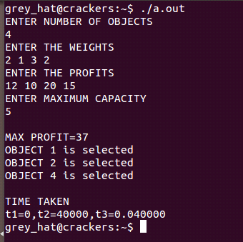

2. When objects selected is commented
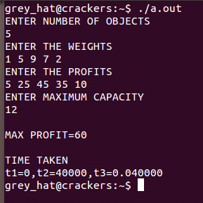

PROGRAM 5

From a given vertex in a weighted connected graph find shortest paths to other vertices using Dijkstra's algorithm

Dijkstra’s algorithm finds shortest paths to a graph’s vertices in order of their distance from a given source. First, it finds the shortest path from the source to a vertex nearer to it, then to a second nearest, and so on.In general,before its i^{th} iteration commences, the algorithm has already identified the shortest paths to i-1 other vertices nearest to the source.
In this algorithm the main focus is to find the shortest path from any vertex to all other remaining vertices.

The following figure demonstrates the application of Dijkstra’s algorithm to a specific graph
b
c
d
a
e
2

7

4

4

3

2

1

The shortest paths and their lengths are
From a to b: 1-2 of length 3
From a to d: 1-2-4 of length 6
From a to c: 1-2-3 of length 5
From a to e: 1-2-4-5 of length 8
Conclusion:

• Doesn’t work with negative weights
• Applicable to both undirected and directed graphs
• Use unordered array to store the priority queue: Efficiency =O (n2)
• Use min-heap to store the priority queue: Efficiency = O(m log n)
ALGORITHM
//Dijkstra’s algorithm for single source shortest paths
//Input: A weighted connected graph G= {V, E} and its vertex s
//Output: The length d_{v} of a shortest path from s to v and its Penultimate vertex p_{v}
for every vertex v in V
Initialize (Q) //initialize vertex priority queue to empty
for every vertex v in V do
d_{v}<— ∞; p_{v}<— null
Insert (Q,v,d_{v}) //initialize vertex priority in the priority queue
d_{s}<— 0; Decrease(Q,s,d_{s}) //update priority of s with d_{s}
V_{T}<— Ø

for i>— 0 to |V| - 1 do
u* <— Delete Min(Q) //delete the minimum priority element
V_{T}<— V_{T}U{u*}

for every vertex u in V-V_{T} that is adjacent to u* do

if d_{u}* + w*(u*,u)<d_{u}
d_{u}<— d_{u}* + w(u*,u); p_{u}<— u*
Decrease (Q,u,d_{u})

5. From given vertex in weighted connected graph find the shortest path to other vertices using Dijkstra's algorithm

#include<stdio.h>
#include<time.h>
int d[20],s[20];
void dij(int cost[10][10],int n,int src)
{
int i,u,min,cnt;
for(i=1;i<=n;i++)
{
s[i]=0;
d[i]=cost[src][i];
}
s[src]=1;
cnt=2;
while(cnt<=n)
{
min=999;
for(i=1;i<=n;i++)
if(d[i]<min&&s[i]==0)
{
min=d[i];
u=i;
}
s[u]=i;
cnt++;
for(i=1;i<=n;i++)
{
if((d[u]+cost[u][i]<d[i]))
d[i]=d[u]+cost[u][i];
}
}
}
int main()
{
clock_t t1,t2;
double t3;
long int u,v;
int i,j,a[10][10],src,n;
printf("ENTER NUMBER OF ELEMENTS\n");
scanf("%d",&n);
printf("ENTER THE COST ADJACENCY MATRIX\n");
for(i=1;i<=n;i++)
for(j=1;j<=n;j++)
{
scanf("%d",&a[i][j]);
if(a[i][j]==0)
a[i][j]=999;
}
printf("ENTER THE STARTING VERTEX\n");
scanf("%d",&src);
t1=clock();
for(u=0;u<10000;u++)
for(v=0;v<1000;v++);
dij(a,n,src);
t2=clock();
printf("SHORTEST PATH FROM SPECIFIED VERTEX ARE\n");
for(j=1;j<=n;j++)
if(j!=src)
printf("%d->%d...%d\n",src,j,d[j]);
t3=(double)(t2-t1)/CLOCKS_PER_SEC;
printf("\nTIME TAKEN\n");
printf("t1=%d,t2=%d,t3=%f\n",t1,t2,t3);
}

OUTPUT:

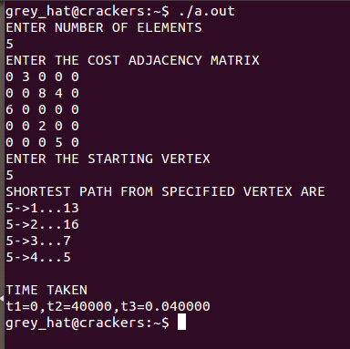

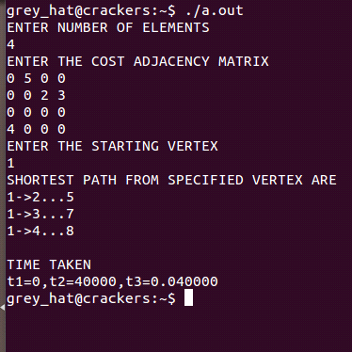

PROGRAM 6
Find Minimum Cost Spanning Tree of a given undirected graph usingKruskal's algorithm.

Kruskal algorithm is an algorithm of obtaining minimum spanning tree of a given graph. In this algorithm always the minimum cost edge has to be selected. But it is not necessary that selected optimum edge is adjacent.

This algorithm begins by sorting the graph’s edges in the increasing order of their weights. Then starting with the empty sub graph, it scans this sorted list adding the next edge in the sorted list to this empty graph. Such that there should be no cycle formation. This process is repeated till the all vertices of the graph are included onto the sub tree.
Efficiency:
Efficiency of Kruskal’s algorithm is based on the time needed for sorting the edge
weights of a given graph.
• With an efficient sorting algorithm: Efficiency: O (|E| log |E|)

Conclusion:
• Kruskal’s algorithm is an “edge based algorithm”
• Prim’s algorithm with a heap is faster than Kruskal’s algorithm.

ALGORITHM :
Kruskal( G )
//Input: A weighted connected graph G = <V, E >
//Output: Et, the set of edges composing a minimum spanning tree of G.
Sort E in increasing order of the edge weight w(e_{i1}) <=…..<= w(e_{i|E|} )

E_{T} = NULL ;ecounter = 0 //initialize the set of tree edges and itz size
K=0 //initialize the number of processed edges

while ecounter< | V | - 1 {
k = k + 1
if E_{T} U { e_{ik} } is acyclic then {
E_{T}= E_{T} U { e_{ik} }
ecounter = ecounter + 1
} // end if
} // end while
return E_{T}

6. Find the minimum cost spanning treee of a given undirected graph using Krushkal's
algoritm

#include<stdio.h>
#include<stdio.h>
#include<time.h>
int parent[10],min,nc=1,mincost=0,cost[10][10];
int i,j,k,a,b,u,v,n;
int main()
{
clock_t t1,t2;
double t3;
system("clear");
printf("ENTER NUMBER OF VERTICES\n");
scanf("%d",&n);
printf("ENTER THE COST ADJACENCY MATRIX\n");
for(i=1;i<=n;i++)
for(j=1;j<=n;j++)
{
scanf("%d",&cost[i][j]);
if(cost[i][j]==0)
cost[i][j]=999;
}
t1=clock();
for(u=0;u<1000;u++)
for(v=0;v<1000;v++);
while(nc<n)
{
for(i=1,min=999;i<=n;i++)
for(j=1;j<=n;j++)
if(cost[i][j]<min)
{
min=cost[i][j];
a=u=i;
b=v=j;
}
while(parent[u])
u=parent[u];
while(parent[v])
v=parent[v];
if(u!=v)
{
printf("\n%d\t(%d,%d)=%d\n",nc++,a,b,min);
mincost+=min;
parent[v]=u;
}
cost[a][b]=cost[b][a]=999;
}
t2=clock();
printf("\nMINCOST=%d",mincost);
t3=(double)(t2-t1)/CLOCKS_PER_SEC;
printf("\nTIME TAKEN\n");
printf("t1=%d,t2=%d,t3=%f\n",t1,t2,t3);
}

OUTPUT:

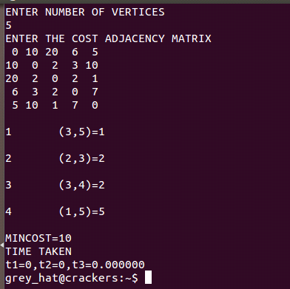

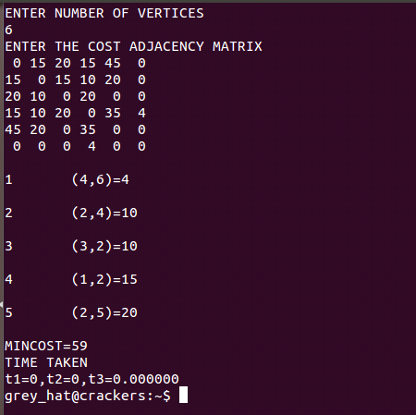

PROGRAM 7

a. Print all the nodes reachable from a given starting node in a
digraph using BFS method.
b.Check whether a given graph is connected or not using DFSmethod.

a. Print all the nodes reachable from a given starting node in a
digraph using BFS method.

Breath first search is a graph algorithm required for processing vertices or edges of a graph in a systematic fashion.

BFS first visits all the vertices that are adjacent to a starting vertex. Every time it adds the adjacent vertex to a queue array q. On each successive iteration of the algorithm, the next vertex on the queue is examined to see if there are any unvisited vertices adjacent to it which can be added to the queue. Whenever a new vertex is taken from the queue, it is marked as a visited node in the visited array.
Applications of BFS:

• To check connectivity of a graph (number of times queue becomes empty tells
the number of components in the graph)
• To check if a graph is acyclic. (no cross edges indicates no cycle)
• To find minimum edge path in a graph

Efficiency:
- Depends on the graph representation:
- Array : O(n2)
- List: O(n + e)

ALGORITHM

BFS(G)
// implements a breadth-first search traversal of a given graph
//Input: Graph G={V,E}
//Output: Graph G with its vertices marked with consecutive integers
//in the order they have been visited by the BFS traversal
Mark each vertex in V with 0 as a mark of being “unvisited”

Count 0
for each vertex v in V do
if v is marked with 0
Bfs(v)
Bfs(v)
//visits all the unvisited vertices connected to vertex by v a path
//and assigns them the numbers in the order they are visited
//via global variable count
count count+1; mark v with count and initialize a queue with v
while the queue is not empty do
for each vertex w in V adjacent to the front vertex do
if w is marked with 0
count count+1; mark w with count
add w to the queue
remove the front vertex from the queue.

7. (a) Print all nodes reachable from a given starting node in digraph using BFS method

#include<stdio.h>
#include<stdlib.h>
#include<time.h>
int f,r,q[10],s[10];
void bfs(int a[10][10],int n,int src)
{
int u,v,i;
r=f=0;
q[0]=src;
for(i=0;i<=n;i++)
s[i]=0;
s[src]=1;
while(f<=r)
{
u=q[f++];
for(v=1;v<=n;v++)
{
if(a[u][v]==1&&s[v]==0)
q[++r]=v;
s[v]=1;
}
}
}
int main()
{
int n,flag=0,a[10][10],i,src,j;
clock_t t1,t2;
double t3;
long int u,v;
printf("ENTER NUMBER OF NODES\n");
scanf("%d",&n);
printf("ENTER ADJACENCY MATRIX\n");
for(i=1;i<=n;i++)
for(j=1;j<=n;j++)
scanf("%d",&a[i][j]);
printf("ENTER SOURCE NODE\n");
scanf("%d",&src);
t1=clock();
bfs(a,n,src);
for(i=0;i<10000;i++)
for(j=0;j<1000;j++);
printf("REACHABLE NODES\n");
for(i=1;i<=r;i++)
if(s[i]==1&&a[i]!=src)
{flag++;
printf("%d\n",q[i]);
}
if(flag==0)
printf("NO NODES ARE REACHABLE\n");
t2=clock();
t3=(double)(t2-t1)/CLOCKS_PER_SEC;
printf("\nTIME TAKEN\n");
printf("t1=%d,t2=%d,t3=%f\n",t1,t2,t3);
}

OUTPUT:

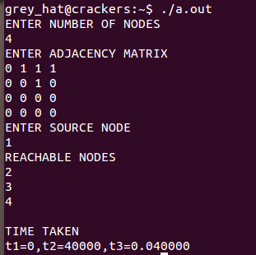

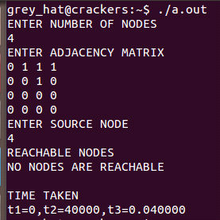

/* Program7b. Check whether a given graph is connected or not using dfs
method */

Depth first search is a graph algorithm required for processing vertices or edges of a graph in a systematic fashion.
Depth first search starts visiting vertices of a graph at an arbitrary vertex by marking it as having been visited. On each iteration, the algorithm proceeds to an unvisited vertex that is adjacent to one it is currently in.
The algorithm backs up one edge to the vertex it came from and tries to continue visiting unvisited vertices from there. The algorithm eventually halts after backing up to starting vertex, with the latter being dead end. By then, all vertices in the same connected component as the starting vertex have been visited. If unvisited vertices still remain, the depth first search must be restarted at any one of them.
Here we use a STACK to trace the depth first search. We push a vertex onto the stack when the vertex is reached for the first time, and we pop a vertex off the stack when it becomes a dead end.
Applications of DFS:

• The two orderings are advantageous for various applications like topological
sorting, etc.
• To check connectivity of a graph (number of times stack becomes empty tells the
number of components in the graph)
• To check if a graph is acyclic. (no back edges indicates no cycle)
• To find articulation point in a graph

Efficiency:
- Depends on the graph representation:
- Adjacency matrix :θ (n2)
- Adjacency list: θ(n + e)
ALGORITHM
DFS (G)
//Implements a depth first search traversal of a given graph
//Input:Graph G= {V, E}
//Output:Graph G with its vertices marked with consecutive integers
//in the order they’ve been first encountered by the DFS traversal
Mark each vertex in V with 0 as a mark of being “unvisited”

count 0
foreach vertex v in V do

if v is marked with 0
dfs(v)
//visits recursively all the unvisited vertices connected to vertex v by a
// path and numbers them in the order they are encounter via global
// variable count

count count+1;mark v with count
for each vertex w in V adjacent to v do
if w is marked with 0
dfs(w)

7. (b) Check whether the given graph is connected or not using DFS method

#include<stdio.h>
#include<stdlib.h>
#include<time.h>
void dfs(int n,int a[10][10],int u,int s[])
{
int v;
s[u]=1;
for(v=1;v<=n;v++)
if(a[u][v]==1&&s[v]==0)
dfs(n,a,v,s);
}
int main()
{
int n,connected=1,a[10][10],s[10],i,j;
clock_t t1,t2;
double t3;
long int u,v;
printf("ENTER NUMBER OF NODES\n");
scanf("%d",&n);
printf("ENTER ADJACENCY MATRIX\n");
for(i=1;i<=n;i++)
for(j=1;j<=n;j++)
scanf("%d",&a[i][j]);
for(j=1;j<=n;j++)
{
for(i=1;i<=n;i++)
s[i]=0;
t1=clock();
for(u=1;u<1000;u++)
for(v=0;v<1000;v++);
dfs(n,a,j,s);
connected=1;
t2=clock();
}
for(i=1;i<n;i++)
{
if(s[i]==0)
connected=0;
}
if(connected==1)
printf("THE GRAPH IS CONNECTED\n");
else
printf("THE GRAPH IS NOT CONNECTED\n");
t3=(double)(t2-t1)/CLOCKS_PER_SEC;
printf("\nTIME TAKEN\n");
printf("t1=%d,t2=%d,t3=%f\n",t1,t2,t3);
}

OUTPUT:

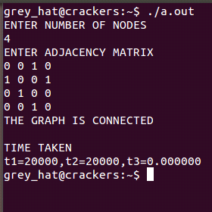

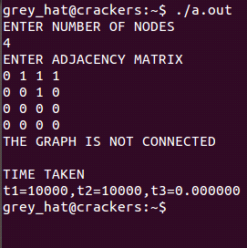

PROGRAM 8
Find a subset of a given set S = {sl, s2,.....,sn} of n positive integers
whose sum is equal to a given positive integer d. For example, if
S={1, 2, 5, 6, 8} and d = 9 there are two solutions{1,2,6}and{1,8}.A
suitable message is to be displayed if the given problem instance
doesn't have a solution.

Description:
Subset-sum problem is to find a subset of a given set S={s1,s2…….sn} of n positive integers whose sum is equal to a given positive integer d.It is assumed that the set’s elements are sorted in increasing order.The state-space tree can then be constructed as a binary tree and applying backtracking algorithm,the solutions could be obtained .Some instance of the problem may be no solution.
ALGORITHM

Backtrack ( X [ 1….i ] )

//Input: X [1….i] specifies first I promising components of a solution.
//Output: All the tuples representing the problem’s solutions
if X [1..i ] is a solution write X [1…i ]
else
for each element x E S _{i+1} consistent with X [1..i ] and the constraints do
X[ i + 1 ] = x

Backtrack ( X [ 1….i + 1 ] )

8. Find a subset of a give set s1={s1,s2,..sn) of n positive integers whose sum is equal to given positive integer 'd'. A suitable message is to be displayed if the given problem instance doesn't have a solution

#include<stdio.h>
#include<stdlib.h>
#include<time.h>
void subset(int n,int d,int w[])
{
int x[20],s,k,i,flag=0;
for(i=1;i<=n;i++)
x[i]=0;
k=1;
x[k]=1;
s=0;
while(1)
{
if((k<=n)&&(x[k]==1))
{
if(s+w[k]==d)
{
printf("SOLUTION IS \n");
for(i=1;i<=n;i++)
{
if(x[i]==1)
printf("%d\t",w[i]);
flag=1;
}
printf("\n");
x[k]=0;
}
else if(s+w[k]<d)
s+=w[k];
else
x[k]=0;
}
else
{
k--;
while((k>0)&&(x[k]==0))
k--;
if(k==0)
break;
x[k]=0;
s-=w[k];
}
k++;
x[k]=1;
}
if(flag==0)
printf("SOLUTION NOT FOUND\n");
}
void main()
{
int n,w[100],d,i;
long int u,v;
clock_t t1,t2;
double t3;
//system("clear");
printf("ENTER THE VALUE OF N\n");
scanf("%d",&n);
printf("ENTER THE SET ELEMENTS\n");
for(i=1;i<=n;i++)
scanf("%d",&w[i]);
printf("ENTER THE VALUE OF D\n");
scanf("%d",&d);
t1=clock();
subset(n,d,w);
t2=clock();
t3=(double)(t2-t1)/CLOCKS_PER_SEC;
printf("TIME TAKEN:\n");
printf("t1=%d,t2=%d,t3=%f\n",t1,t2,t3);
}

OUTPUT:

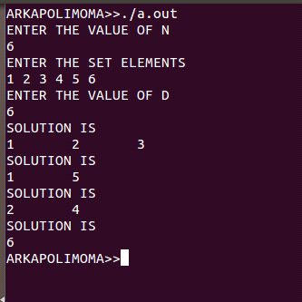

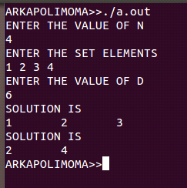

PROGRAM 9
Implement any scheme to find the optimal solution for the Traveling Salesperson problem and then solve the same problem instance using any approximation algorithm and determine the error in the approximation.
Travelling salesman problem refers to the problem of a travelling salesman who begins the travel from the home town and has to visit all other towns without skipping any town or without visiting a town more than once. Further the cost of his travel has to be the least.

Algorithm
Step1: Construct a minimum spanning tree of the graph corresponding to a given instance of the
Travelling salesman problem.
Step 2: Starting at the arbitrary vertex, walk around the minimum spanning tree recording all the
vertices Passed by.
Step 3: Scan the vertex list obtained in step 2 and eliminate from it all repeated occurrences of the same
vertex except the starting one at the end of the list. The vertices remaining on the list will form a
Hamiltonian circuit, which is the output of the algorithm

9. Implement any scheme to find the optimal solution for the travelling salesperson problem and then solve the same problem instance using any approximation algoritm and determine error in the approximation

(a)

#include<stdio.h>
#include<stdlib.h>
#include<time.h>
int d[100],min_dist,a[100][100],source,n,no_of_solution=0;
void distance(int s,int visit[],int numbers,int path[],int dist);
int optimal();
int main()
{
clock_t t1,t2;
double t3;
int i,j,u,v,dist=0;
int visit[10]={0},path[10]={0};
printf("ENTER NUMBER OF CITIES\n");
scanf("%d",&n);
printf("ENTER THE SOURCE VERTEX\n");
scanf("%d",&source);
printf("ENTER THE ADJACENCY MATRIX\n");
for(i=1;i<=n;i++)
for(j=1;j<=n;j++)
scanf("%d",&a[i][j]);
visit[source]=1;
path[1]=source;
t1=clock();
distance(source,visit,2,path,dist);
for(u=0;u<1000;u++)
for(v=0;v<1000;v++)
min_dist=optimal();
printf("\nTHE OPTIMAL SOLUTION IS %d\n",min_dist);
for(i=0;i<=no_of_solution;i++)
if(min_dist==d[i])
printf("POSSIBLE PATH(S) CAN BE THE SOLUTION NO:%d\n",i);
t2=clock();
t3=(double)(t2-t1)/CLOCKS_PER_SEC;
printf("TIME TAKEN:\n");
printf("t1=%d,t2=%d,t3=%f\n",t1,t2,t3);
}
int optimal()
{
int i,min=d[0];
for(i=0;i<no_of_solution;i++)
if(min>d[i])
min=d[i];
return min;
}
void distance(int s,int visit[],int no,int path[],int dist)
{
int i,j,flag=0;
for(i=1;i<=n;i++)
if(visit[i]==0)
{
flag=1;
visit[i]=1;
path[no]=i;
distance(i,visit,no+1,path,dist+a[s][i]);
visit[i]=0;
}
if(flag==0)
{
printf("SOLUTION %d\n\t PATH IS ",no_of_solution);
for(i=1;i<=n;i++)
printf("%d->",path[i]);
printf("%d DISTANCE:%d\n",source,dist+a[s][source]);
d[no_of_solution++]=dist+a[s][source];
}
}
OUTPUT:
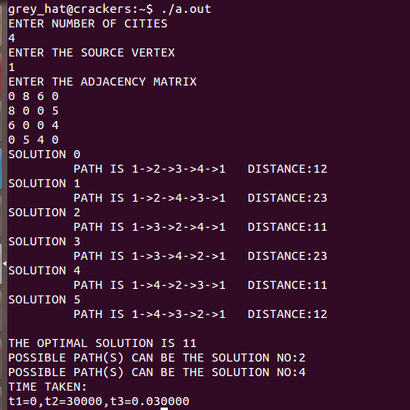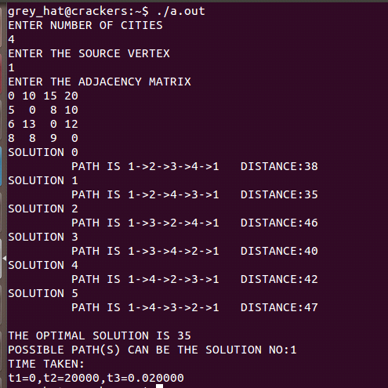

(b)

#include<stdio.h>
#include<stdlib.h>
int d[100],a[100][100],source,n,no_of_solution=0;
void distance(int s,int visit[],int numbers,int path[],int dist);
int find_min(int row,int min_count);
int main()
{
int i,j,min_dist,dist=0,visit[10]={0},path[10]={0};
printf("ENTER NUMBER OF CITIES\n");
scanf("%d",&n);
printf("ENTER THE SOURCE VERTEX\n");
scanf("%d",&source);
printf("ENTER THE ADJACENCY MATRIX\n");
for(i=1;i<=n;i++)
for(j=1;j<=n;j++)
scanf("%d",&a[i][j]);
visit[source]=1;
path[1]=source;
distance(source,visit,2,path,dist);
}
void distance(int s,int visit[],int no,int path[],int dist)
{
int i,min,flag=0;
for(i=1;i<=n;i++)
{
min=find_min(s,i);
if(visit[min]==0)
{
flag=1;
visit[min]=1;
path[no]=min;
distance(min,visit,no+1,path,dist+a[s][min]);
visit[min]=0;
flag=0;
}
}
if(flag==0)
{
if(a[s][source]!=0)
{
d[no_of_solution++]=dist+a[s][source];
printf("SOLUTION PATH IS \n");
for(i=1;i<=n;i++)
printf("%d->",path[i]);
printf("%d\n\n",source);
printf("DISTANCE:%d\n",dist+a[s][source]);
exit(0);
}
else if(s==source)
printf("NO SOLUTION");
}
}
int find_min(int row,int min_count)
{
int i,j,mini=0,min_cost,min[100]={0};
for(j=1;j<=min_count;j++)
{
for(i=1;i<=n;i++)
{
mini=0;
min_cost=999;
if(i!=row&&a[row][i]!=0&&min[i]!=1)
{
mini=i;
min_cost=a[row][i];
min[i]=1;
break;
}
}
}
return mini;
}
OUTPUT:
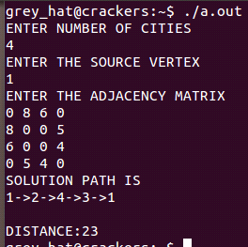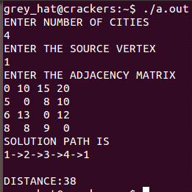

PROGRAM 10
Find Minimum Cost Spanning Tree of a given undirected graph
using Prim’s algorithm.

Prims algorithm is a classic example for the application of greedy technique. It is used to obtain the minimum spanning tree of a given graph.
Prims algorithm constructs a minimum spanning tree through a sequence of expanding subtrees.On each iteration,we simply expand its current subtree by attaching to it the nearest vertex which not in the current subtree.The algorithm stops after all the vertices in the given graph are included onto the subtree.

Efficiency:
Efficiency of Prim’s algorithm is based on data structure used to store priority queue.
• Unordered array: Efficiency:θ(n2)
• Binary heap: Efficiency: θ(m log n)
• Min-heap: For graph with n nodes and m edges: Efficiency: (n + m) log n

ALGORITHM
Prim (G)
// Prim’s algorithm for constructing a minimum spanning tree
// Input : A weighted connected graph G = ( V,E )
// Output : E_{T}, The set of edges composing of a minimum spanning tree of G

V_{T} ← { V₀ }
E_{T} ← Ø
for i ← 1 to |V| - 1 do
find a minimum-weight edge e* = ( v*,u* ) among all the edges (v,u) such that v is in V_{T}
and u is in V - V_{T}
V_{T} ← V_{T} U { u* }
E_{T} ← E_{T} U { e* }

return E_{T}

10.Find the minimum cost spanning tree of a given undirected graph using Prim's Algorithm.

#include<stdio.h>
#include<stdlib.h>
#include<time.h>
void prim(int g[100][100],int n)
{int u,v,min,mincost=0,included[200],i,j,k;
for(i=1;i<n;i++)
included[i]=0;
included[1]=1;
for(k=1;k<=n-1;k++)
{min=999;
u=1;
v=1;
for(i=1;i<=n;i++)
{if(included[i]==1)
for(j=1;j<=n;j++)
{if(g[i][j]<min)
{min=g[i][j];
u=i;
v=j;
}
}
}
mincost+=min;
included[v]=1;
printf("THE MINIMUM COST OF SPANNING TREE IS:\n");
printf("\n<%d,%d>=%d\n",u,v,min);
for(i=1;i<=n;i++)
for(j=1;j<=n;j++)
if(included[i] && included[j])
g[i][j]=g[j][i]=999;
}
}
int main()
{ int n,j,a[100][100];
long int i,k;
clock_t t1,t2;
double t3;
printf("ENTER NUMBER OF NODES:\n");
scanf("%d",&n);
printf("ENTER THE COST ADJACENCY MATRIX\n");
for(i=1;i<=n;i++)
{ for(j=1;j<=n;j++)
{
scanf("%d",&a[i][j]);
if(a[i][j]==0)
a[i][j]=999;
}
}
t1=clock();
for(k=0;k<5000;k++)
for(i=0;i<5000;i++);
prim(a,n);
t2=clock();
t3=(double)(t2-t1)/CLOCKS_PER_SEC;
printf("TIME TAKEN:\n");
printf("t1=%d,t2=%d,t3=%f\n",t1,t2,t3);
}

OUTPUT:
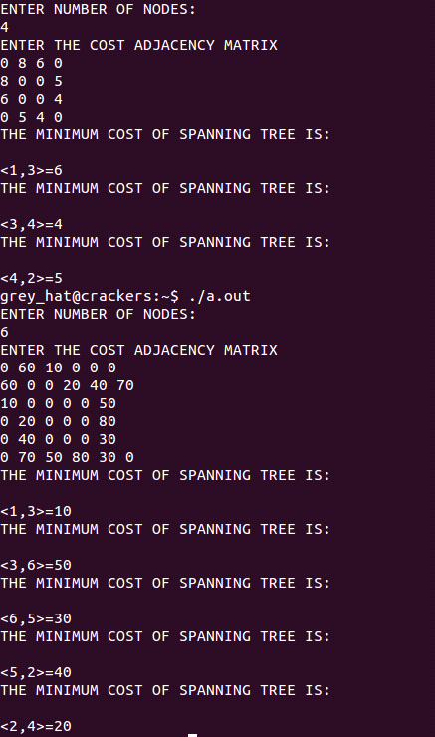

PROGRAM 11
Implement All-Pairs Shortest Paths Problem using Floyd's algorithm. Parallelize this algorithm, implement it using OpenMP and determine the speed-up achieved.
Floyds algorithm is a classic example for the application of dynamic programming.It is used to compute the shortest distance between every two pair of nodes in a given graph and hence it is also called “all-pair shortest path” algorithm
The following formula can be used to find the each element in the distance matrix.
d^{(k)}_{ij}←min{d^{(k-1)}_{ij}, d^{(k-1)}_{ik}+ d^{(k-1 )}_{kj}} where k>=1,d⁽⁰⁾_{ij}←w_{ij}
ALGORITHM
Algorithm Floyd(W[1..n, 1..n])
// Implements Floyd’s algorithm
// Input: Weight matrix W
// Output: Distance matrix of shortest paths’ length
D⁽⁰⁾←w
for k←1 to n do
for i←1 to n do
for j←1 to n do
D^{(k)}←min{d^{(k-1)}[i,j], d^{(k-1)}[i,k]+d^{(k-1)}[k,j]}
ReturnD^{(n)}

11. Implement All-Pairs shortest paths problem using Floyd's algorithm. Parallelize this algoritm, implrment it using OpenMP and determine the speed up acieved.

#include "omp.h"
#include<stdio.h>
#include<stdlib.h>
#include<time.h>
int min(int a,int b)
{
if(a<=b)
return a;
else
return b;
}
int main()
{
int a[100][100],n,i,j,k,x,y,z,m=0;
clock_t t1,t2;
double t3;
printf("ENTER THE NUMBER OF NODES:\n");
scanf("%d",&n);
printf("\nENTER THE COST ADJACENCY MATRIX:\n");
for(i=1;i<=n;i++)
for(j=1;j<=n;j++)
{
scanf("%d",&a[i][j]);
if(a[i][j]==0&&i!=j)
a[i][j]=999;
}
t1=clock();
for(x=0;x<1000;x++)
for(y=0;y<1000;y++)
for(z=0;z<1000;z++);
#pragma omp single
printf("\n THE NUMBER OF THREADS ARE %d\n",omp_get_num_threads());
#pragma omp parallel
for(k=1;k<=n;k++)
for(i=1;i<=n;i++)
{
#pragma omp parallel for shared (a)
for(j=1;j<=n;j++)
a[i][j]=min(a[i][j],a[i][k]+a[k][j]);
}
printf("\nOUTPUT\n");
for(i=1;i<=n;i++)
{
for(j=1;j<=n;j++)
printf("%d\t",a[i][j]);
printf("\n");
}
t2=clock();
t3=(double)(t2-t1)/CLOCKS_PER_SEC;
printf("TIME TAKEN:\n");
printf("t1=%d,t2=%d,t3=%f\n",t1,t2,t3);
}

OUTPUT:
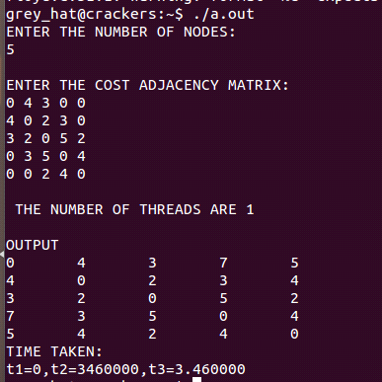
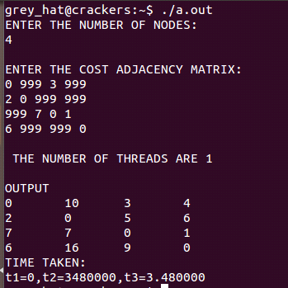

NOTE:

As this is parallel program number of threads created depends on system architecture.

PROGRAM 12
Implement N Queen's problem using Back Tracking.

Backtracking algorithm is based on the construction of a statespacetree.The nodes of a tree reflects the specific choice made by the programmer while finding the solution.If there is no legitimate option for the next candidate, then the progress along that node is terminated. In such case the algorithm replaces the last component of the partially constructed solution with its next option.
N Queen problem is to place n queens on an n by n chess board so that no two queens attack each other by being in the same row or in the same column or the same diagonal.

ALGORITHM
ALGORITHM Queens(x[1..i])
//Gives a template of a generic backtracking ALGORITHM
//Input :x[1..i]specifies components of a solution
//Output: All the tuples representing the problem solution

if x[1..i] is a solution write x[1..i]
else
for each element x є S_{i+1} consistent with x[1..i] and the constraints do
x[i+1] ← x
Queens(x[1..i+1])

12. Implement N Queen's problem using Back Tracking

#include<stdio.h>
#include<stdlib.h>
#include<time.h>
void print_solution(int x[],int n)
{
char ch[25][25];
int i,j;
for(i=1;i<=n;i++)
{
for(j=1;j<=n;j++)
{
if(x[i]==j)
printf("Q\t");
else
printf("X\t");
}
printf("\n");
}
}
int place(int x[],int k)
{
int i;
for(i=1;i<k;i++)
{
if(x[i]==x[k]||i-x[i]==k-x[k]||i+x[i]==k+x[k])
return 0;
}
return 1;
}
void nqueens(int n)
{
int k=1,x[10],count=0;
x[k]=0;
while(k!=0)
{
x[k]+=1;
while((x[k]<=n)&&(!place(x,k)))
x[k]+=1;
if(x[k]<=n)
{
if(k==n)
{
count++;
printf("\n THE SOLUTION COUNT IS:\n",count);
print_solution(x,n);
}
else
{
k++;
x[k]=0;
}
}
else
k--;
}
return;
}
int main()
{
int n;
long int u,v;
clock_t t1,t2;
double t3;
printf("ENTER THE VALUE OF n\n");
scanf("%d",&n);
t1=clock();
nqueens(n);
for(u=0;u<1000;u++)
for(v=0;v<1000;v++);
t2=clock();
t3=(double)(t2-t1)/CLOCKS_PER_SEC;
printf("\nTIME TAKEN\n");
printf("t1=%d,t2=%d,t3=%f\n",t1,t2,t3);
}
OUTPUT:
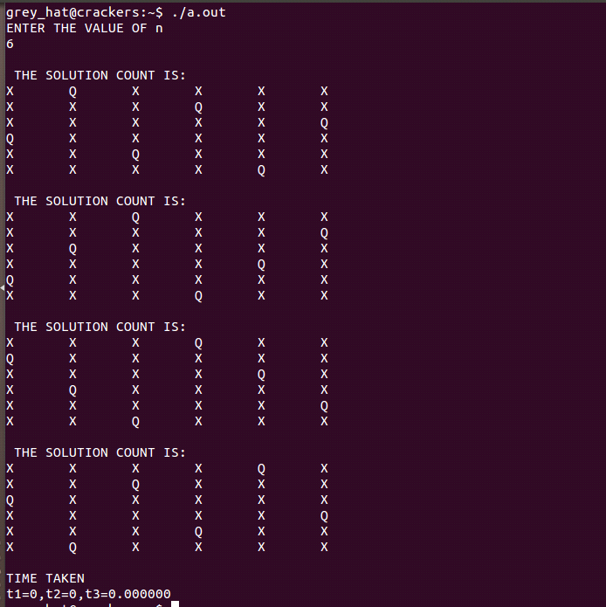

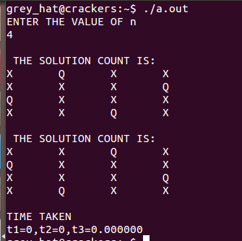

Viva Questions
- What is an algorithm?
An algorithm is a sequence of unambiguous instructions for solving a problem, i.e., for obtaining a required output for any legitimate input in a finite amount of time.

- What are the 3 ways of computing GCD?
a. Euclid’s algorithm
b. Consecutive integer checking algorithm
c. Middle school procedure.

- What is a pseudo code?
A pseudo code is a mixture of a natural language and programming language.

- What is a flow chart?
Flow chart is a diagrammatic representation of an algorithm.

- Name some important problem types in algorithm.
The important problem types are: Sorting, Searching, String Processing, Graph problems, Combinatorial Problems, Geometric Problems and Numeric Problems

- What is an adjacency matrix?
The adjacency matrix of a graph with n vertices is a n-by-n boolean matrix with one row and one column for each of the graph’s vertices, in which the elements in the i^{th} row and the j^{th} column is equal to 1 if there is an edge from the i^{th} vertex to j^{th} vertex and equal to 0 if there is no such edge.

- What is an adjacency Linked list
The adjacency list of a graph is a collection of linked lists, one for each vertex, that contains all the vertices adjacent to the list’s vertex.

- Define weighted digraph
A graph with number assigned to its edges are called weighted graph

- What is a tree?
A tree is a connected acyclic graph.

- What is forest?
A graph that has no cycles but is not necessarily connected is called the forest .
- What is a Rooted tree?
Rooted tree are trees where for every two vertices in a tree, there always exists exactly one simple path from one of these vertices to the other.

- What is a binary tree?
A binary tree is a tree in which each node has at most two children. Each child in the graph is designated as left child or right child.

- Define ancestors of a tree.
All the vertices on the simple path from root to the vertex “v” are called as ancestor of v.

- Define siblings of a tree
Vertices that have the same parent are said to be siblings.

- What is a leaf?
A vertex with no children is called a leaf.

- Define parent of a tree
A vertex with at least one child is called parent.

- What is a binary search tree?
A binary search tree is a binary tree in which a number assigned to each parental vertex is larger than all the numbers in its left subtree and smaller than all the numbers in the right subtree.

- What is an ordered tree?
An ordered tree is a rooted tree in which all the children of each vertex are ordered.

- What is a set?
A set is defined as an unordered collection of distinct items called an elements of the set.

- What is a dictionary?
Dictionary is a data structure that implements the searching, addition and deletion operations on the set.
21.What is a bag or multiset?
It is an unordered collection of items that are not necessarily distinct.

22.What is an abstract data type?
ADT is a set of abstract objects representing data items with a collection of operations that can be performed on them.
23.What are the two kinds of efficiency?
Time efficiency and space efficiency.

24. Define time and space efficiency.
Time efficiency indicates how fast an algorithm in question runs.Space efficiency deals with the extra space the algorithm requires.

25.Whatis an asymptotic notations?
Asymptotic notation is a way of comparing functions that ignores constant factors and small input sizes.
Three notations used to compare orders of growth of an algorithm’s
basic operation count are: O, Ω, θ notations.

26.Define Big O notation.
A function t(n) is said to be in O(g(n)),denoted t(n)€O(g(n)),if t(n) is bounded above by some constant multiple of g(n) for all large n i.e., if there exist some positive constant c and some nonnegative integer n۪₀ such that t (n)<=cg(n) for all n>= n₀

27. Define Big- Ω omega notation.
A function t(n) is said to be in Ω(g(n)),denoted t(n)€ Ω(g(n)),if t(n) is bounded below
by some constant multiple of g(n) for all large n i.e., if there exist some positive constant c
and some nonnegative integer n۪₀ such that
t(n)>=cg(n) for all n>=n₀

28.DefineBig- θ theta notation.
A function t(n) is said to be in θ(g(n)),denoted t(n)€ θ(g(n)),if t(n) is bounded both above and below by some positive constant multiple of g(n) for all large n i.e., if there exist some positive constant c and some nonnegative integer n۪₀ such that
c2g(n)<=t(n)<=c1g(n) for all n>= n₀

29.Explain basic efficiency classes?
Average case efficiency, Best-case efficiency and worst- case efficiency.

30.Define order of growth.
Measuring the performance of an algorithm in relation with the input size n is called order of growth.
31.Explain Brute force method. Give an example
Brute force is a straightforward approach to solving a problem, usually directly based on the problems statements and the definitions of the concepts involved.
Ex: Selection sort, bubble sort.
32.What is a best case efficiency?
It is an efficiencyfor the best case input of size n for which the algorithm runs the fastest among all possible inputs of size n.

33. What is a Worst-case efficiency?
It is an efficiencyfor the worst case input of size n.for. The algorithm runs the longest among all possible inputs of size n.

34. What is anAverage-case efficiency?
It is an efficiency for which Average time taken to solve all the possible instances (random) of the input.

35..Explain Divide and conquer method. Give an example
Divide and conquer is a top-down technique for designing algrithms that consist of dividng the problem into smaller subproblems. The solution of all smaller problems are then combined to get the solution for the original problem. Ex:quicksort,merge sort.
36.What is a merge sort?
Merge sort is a sort algorithm that splits the items to be sorted into two groups,
recursively sorts each group, and merges them into a final sorted sequence
37.Explain Decrease and conquer method. Give an example
Decrease & conquer is a general algorithm design strategy based on exploiting the
relationship between a solution to a given instance of a problem and a solution to a
smaller instance of the same problem. The exploitation can be either top-down
(recursive) or bottom-up (non-recursive).Ex:insertion sort.
38.What do you mean by insertion sort?
It is a comparison based sort in which the sorted array is built on one entry at a time.

39.What is a topological sorting?
Topological sorting is a sorting method to list the vertices of the graph in such an order
that for every edge in the graph, the vertex where the edge starts is listed before the
vertex where the edge ends.
It refers to the process of vising the vertices of a given graph in such a order that all the independent vertices are visited first followed by the dependent vertices.

40. define transform and conquer technique?
Transform & Conquer is a general algorithm design technique which works in two stages.
STAGE 1: (Transformation stage): The problem’s instance is modified, more
amenable to solution
STAGE 2: (Conquering stage): The transformed problem is solved

41. What is an AVL tree?
An AVL tree is a binary search tree in which the balance factor (defined as:
difference between the heights of the node’s left and right sub-trees) of every node is
either 0 or +1 or -1.
42.What is rotation in AVL tree?
A rotation in an AVL tree is a local transformation of its sub-tree rooted at a node whose
balance has become either +2 or -2.

43.What are the four types of rotation?
4 types of rotations are:
1. Single R – rotation
2. Single L – rotation
3. Double LR – rotation
4. Double RL – rotation
44. What is an 2-3 tree?
2-3 tree is a height balanced search tree, that has all its leaves on the same level and can have nodes of two kinds: 2node and 3 node

45.What is a heap?
A heap is a binary tree with keys assigned to its nodes, provided the following two
conditions are met:
i. Tree’s shape requirement: The binary tree is essentially complete, all its level
are full except possibly the last level, where only some rightmost leaves may be
missing.
ii. Parental dominance requirement: The key at each node is greater than or equal
to the keys at its children.

46.Explain greedy technique. Give an example
Greedy technique is a general algorithm design strategy, built on following elements:
• configurations: different choices, values to find
• objective function: some configurations to be either maximized or minimized
47.What is a spanning tree?
Spanning tree is a connected acyclic sub-graph (tree) of the given graph (G) that includes all of G’s vertices

48.What is a minimum spanning tree?
MST of a weighted, connected graph G is defined as: A spanning tree of G with
minimum total weight.

49.Why can’t we use BRUTE FORCE method in constructing MST ?
If we use Brute force method-
• Exhaustive search approach has to be applied.
• Two serious obstacles faced:
1. The number of spanning trees grows exponentially with graph size.
2. Generating all spanning trees for the given graph is not easy.

50.What is a fringe edge?
An edge which has one vertex is in partially constructed tree Ti and
the other is not.

51.What is a code word?
Encoding a text that comprises n characters from some alphabet by assigning to each of the text’s characters some sequence of bits. This bits sequence is called code word.

52.What is a dynamic programming?
Dynamic programming (DP) is a general algorithm design technique for solving
problems with overlapping sub-problems. Ex:Knapsack problem

53.What is a binomial co-efficient?
The binomial co-efficient C(n,k) is the number of ways of choosing a subset of k
elements from a set of n elements.

54.What is a directed graph?
A graph whose every edge is directed is called directed graphOR digraph

55.What is a decision tree?
Decision tree is a convenient model of algorithms involving Comparisons in which: (i)
internal nodes represent comparisons (ii) leaves represent outcomes

56.What is an adversary argument?
Adversary argument is a method of proving a lower bound by playing role of adversary that makes algorithm work the hardest by adjusting input
Example: “Guessing” a number between 1 and n with yes/no questions
Adversary: Puts the number in a larger of the two subsets generated by last question

57.What is lower bound?
Lower bound is defined as estimating the minimum amount of time needed to solve a given problem.
58.What are the methods of obtaining lower bounds?
Methods to obtain lower bounds are: Trival lower bound, Information-theorticalarguments,adversary arguments ,problemreduction.
59.What is P class?
P class problem consists of decision problem that can be solved in polynomial time by deterministic algorithms Ex:searching and sorting.
60.What are NP_complete problems?
The NP-problems are NP-complete if their solutions can be verified quickly for correctness and if the same algorithm used can solve all other NP probles. Ex:sum of subset problem
61.What are NP-hard problem?
NP-hard is a class of problems that are at leasts as hard as hardest problem in NP .Ex:decision problems and optimization problems.
62.What is a Huffman tree?
A Huffman tree is a binary tree that minimizes the weighted path length from the root to the leaves of predefined weights
63.What is a prefix code?
A prefix code is a codeword where in no code word is the prefix of another character.
64.What are the two types of encoding schemes?
The two types of encoding schemes are: Fixed-length encoding and variable length encoding.
65.What are the applications of MST?
They are helpful in routing applications
Communication networks
66.What is clustering?
Clustering is a phenomenon where the data tend to cluster (gather) at certain points in the table,with other part of the table not being used.
67. What is hashing?
Hashing is the process of transforming a string of characters into a short integer value which is used as index to het the original string.
68.What is hash function?
The function that is used to generate a hash value is called hash function.
69.What is a priority queue?
A priority queue is a data structure that enables the selection of an item of highest priority among dynamically changed set of items.
70.What is a knapsack problem?
It refers to the problem of selecting a set of items from a total of n items with varying weights and varying values such that the total weight of selected items must not exceed the knapsack capacity.
71.Explain the 3 major variations of decrease and conquer
The 3 major variations of decrease and conquer are:
- decrease by a constant
- decrease by a constant factor
- variable size decrease
72.What is BFS?
Breadth first search is a traversal method that proceeds in a concentric manner by visiting first all the vertices that are adjacent to the starting vertex.Than all unvisited vertices two edge apart from it are visited.This process continues until all vertices of the graph are visited.

73.What is DFS?
Depth first search is traversal method in which on each iteration, the algorithm proceeds to an un-visited vertex that is adjacent to the one that is currently in. This process continues until a dead-end is encountered.
74. What are the algorithms for generating combinatorial objects?
Johnson trotter algorithm,bottom up minimal change algorithm and lexicographic algorithm.
75.What is meant by problem reduction?
Problem reduction is a method of solving problem in which the given problem is reduced to another problem for which the solution is known.
76.ExplainHorspool algorithm.
It is string matching algorithm that uses the technique called input enhancement to search for the pattern of a given text
77.What is closed hashing?
It is a collision resolution technique in which a key is hashed onto its position in the table if the position is vacant.If it is not vacant then it would be hashed onto the next available vacant position.
78. Explain n-queens & sum of subsets problem with respect to backtracking.
It refer to the probem of placing n-queens on a n by n chess board such that no 2 queens attack each other by being in the same row or in the same column or on the same diagonal.

79.What is a bubble sort?
Bubble sort is an algorithm in which it Compare adjacent elements of the list and exchange them if they are
out of order.Then we repeat the process,By doing it repeatedly, we
end up ‘bubbling up’ the largest element to the last position on the list
80.What is a Huffman code?
A Huffman code is an optimal prefix-free variable length encoding scheme that assign bit strings to characters based on their frequencies in a given text.
81.What is a Prim’s algorithm?
It is a greedy algorithm for constructing a minimum spanning tree of a weighted connected graph.It works by attaching to a previously constructed subtree a vertex closest to the vertices already in the tree.
82.What is an algorithm design technique?
Algorithm design technique are general approaches to solving problems algorithmically, applicable to a variety of problems from different areas of computing.
83.What is an algorithm visualization?
Algorithm visualization is the use of images to convey useful information about algorithms.
84.Define exhaustive search?
Exhaustive search is brute force approach to combinatorial problems. It suggests generating each and every combinatorial object to the problem,selecting those to them that satisfy all the constraints, and then finding a desired object.
85.What is a quick sort?
Quick sort is a divide and conquer sorting algorithm that works by partitioning its input’s elements according to their value relative to some preselected elements.
86.What are the three principal variations of the transform and conquer strategy?
The principal variations are: Instance simplification, representation change and problem reduction.
87.What is an instance simplification?
Instance simplification is a technique of transforming an instance of a problem to an instance of the same problem with some special property that makes the problem easier to solve.
88.What is a Horner’s rule?
It is an optimal algorithm for polynomial evaluation without coefficient preprocessing.
89.What is a distribution counting?
Distribution counting is a special method for sorting lists of elements from a small set of possible values.
90. What is a Kruskal algorithm?
Kruskal algorithm is a greedy algorithm for the minimum spanning tree problem in which it constructs a minimum spanning tree by selecting edges in increasing order of their weight provided that the inclusion does not create a cycle.
91.What is a simplex method?
The simplex method is the classic method for solving the general linear programming problem.It works by generating a sequence of adjacent extreme points of the problem’s feasible region with improving values of theobjective function.
92.What is a branch and bound?
Branch and bound is an algorithm design technique that enhance the idea of generating a state-space tree with the idea of estimating the best value obtainable from a current node of the decision tree.
93.What is a numerical analysis?
Numerical analysis is a branch of computer science dealing with solving continuous mathematical problems.
94.DefineDijkstar’s algorithm?
Dijkstar’s algorithm is an algorithm that solves the single-shortest path problems of finding shortest path from a given vertex(the source) to all other vertices of a weighted graph or digraph.
95.What is B-tree?
The B-tree is a balanced search tree that generalizes the idea of the 2-3 tree by allowing multiples key at the same node.

96.What is a Gaussian elimination?
It is an algorithm for solving systems of linear equations. It solves a system by transforming it to an equivalent system with an upper-triangular coefficient matrix,which is easy to solve by backward substitutions.
97. What is a binary search?
Binary search is algorithm for searching in sorted arrays.
98. Is selection sort stable algorithm?
No.selection sort is not a stable algorithm because in this method the ordering a similar elements is not maintained.
99.What is amortized analysis?
Amortized analysis means finding the average running time per operation over a worst case sequence of operations.
100.What are the two important properties of sorting?
The two important properties are:
- Stable property: the algorithm is said to be stable if it preserves the relative ordering of items with equal values.
- Inplace :the algorithm is said to be in in-place if it does not require extra memory while sorting the list.

Part-b

1) How might we think of a binary tree as a graph ?
A binary tree is a directed acyclic graph with the following characteristics. Each node has up to two edges incident from it and one edge incident to it, except for the root node, which has only the two edges incident from it. Edges incident from a vertex connect it with its children. The edge incident to a vertex connects its parent to it. Thus, the adjacency list of each vertex contains its children.

2) Suppose we need to sort all of the customer records for a worldwide investment firm by name . The data is so large it cannot be fit into memory all at once. Which sorting algorithm should we use ?
Merge sort. Aside from running efficiently in 0(n log n) time, the predictable way that merge sort divides and merges the data lets us easily manage the data ourselves to efficiently bring it in and out of secondary storage.

3) Suppose we are maintaining a list of sorted elements in a user interface. The list is relatively small and the elements are being entered by a user one at a time. Which sorting algorithm should we use ?
Insertion sort. The runtime complexity of insertion sort when inserting a single elements into a list that is already sorted is 0( n ).

4) Suppose We need to sort 10,000 C structures containing information about the flight schedule for an airline. Which sorting algorithm should we use?
Quick sort. It is the best general –case sorting algorithm and is excellent for medium to large sets of data.
5) In the implementations presented for computing minimum spanning trees and shortest paths, weighted graphs are represented by storing the weights of edges in the graphs themselves. What is an alternative to this ?

A more general way to think of an edge’s weight is as a function w(w,v) where u and v are the vertices that define the edge to which the weight function applies. To determine the weight of an edge, we simply call the function as needed. An advantage to this approach is that it lets us compute weights dynamically in applications where we expect weights to change frequently. On the other hand, a disadvantage is that if the weight function is complicated, it may be inefficient to compute over and over again.

